**Weeding Decisions for a High Volume Digital Photo Transfer**

Alabama Department of Archives and History

This memorandum serves as an introduction to the use of weeding in the processing of Alabama Governor Bob Riley (2003-2011) digital photos. The memo will first introduce the archival concept of weeding generally before turning to a discussion of the specific process used at the Alabama Department of Archives and History (ADAH). Photo examples are included.

**I. Background**

In the age of digital cameras, “photography is cheap and almost effortless.” Indeed, photography in the digital age has led to a proliferation in the numbers of photos taken in both private and public contexts.[1] For archivists, this proliferation can have very real implications for workload – particularly when records creators practice limited records management in advance of transfer.

This workload impact can be observed clearly in the archival practice called weeding. The Society of American Archivists (SAA) defines weeding as “[t]he process of identifying and removing unwanted materials from a larger body of materials.”[2] These unwanted materials may include “duplicates and documents without archival value.”[3] Weeding is not new; in fact, it is a widespread practice, as according to one survey of repositories, “92% sometimes, usually, or always weed duplicates from twentieth-century collections[.]”[4]

ADAH Collections staff believe that weeding can produce marked benefits to the Department, including improving researcher access and decreasing long-term digital storage costs.

**II. The Riley Photo Transfer**

ADAH received a large volume of photos from the Governor Riley administration—1.58 TB or about 236,000 files. The project team expects this volume to increase with the Governor Robert Bentley (2011-2017) transfer.

ADAH Collections staff have noted that in the past, only the best photos of an event would make it to the Archives – the bad ones would not have made it past the developing room. But Collections staff believe that ADAH received basically “everything” from Governor Riley in terms of photos. Records management was not undertaken in advance of transfer, and thus the Archives likely received virtually every photo taken, even if the photo was not used as final product in any way. A dozen or more photos of the same event – even from the same camera angle – may have been transferred, with only the slightest of variations.

Collections staff believe that many of these photos would not be considered “official photographs” per the Office of the Governor’s Records Disposition Authority (RDA). They would likely be considered transitory drafts rather than permanent records. Per the RDA, both transitory items and duplicates “may be disposed of without documentation of destruction.”[5]

Ultimately, Collections staff determined that item-level processing of the photos, including weeding, should occur. Collections staff believe that this weeding can be accomplished without the loss of historical content or permanent records.

**III. Weeding Process**

Collections Archivist Rachel Smith uses a duplicate file finder tool (which checks hash algorithms of files) to search for exact copies of photos. This search is automated. When there are two exact copies of the same photo, one of the copies is deleted.

Government Records Archivist Cole Smith performs the initial weeding review for everything other than exact copies of photos. Cole looks at each photo. If he believes the photo should be weeded out, he moves the file to a separate weeding folder for peer review. No photos will be deleted until after peer review.

**IV. Weeding Timeline**

Based on current work trends, Collections staff project that Cole’s weeding step will be completed for all Riley photos by the end of 2017. Review and deletion would occur in 2018.

**V. Types of Weeding at ADAH and Example Photos**

The following pages include examples demonstrating Cole’s weeding work.

**1. Weeding of Highly Similar Photos**

Example 1.1 – General

Many times, multiple photos were taken to ensure the best end product. This resulted in multiple highly similar photos with only very minor variations in focus, lighting, or angle. In this case, the reviewing archivist recommended weeding out all but one of the highly similar photos.

* Highly Similar Photos Received

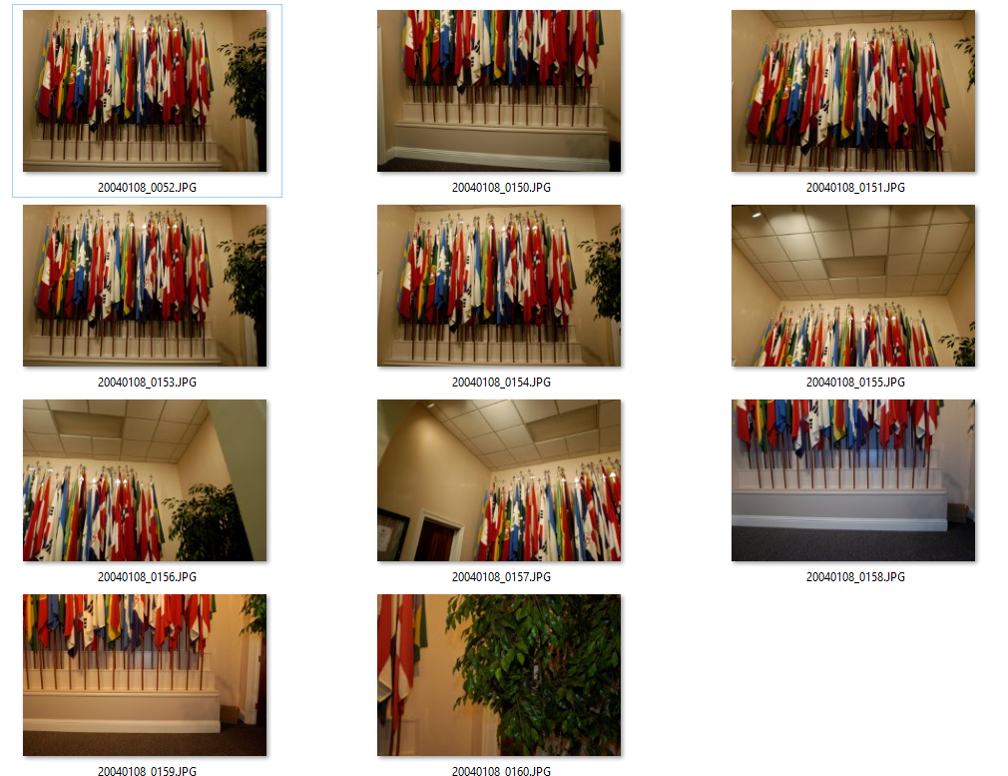

* Photo to Keep (All Others Weeded Out)

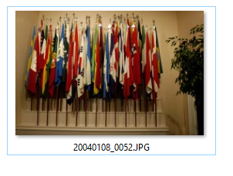

Example 1.2 – Processed and Unprocessed Versions

Some photos have both an original and processed version. The term “processed” here means photography post-production (not archival processing), which includes tasks like fixing the lighting, cropping, and performing other touch-ups.[6] When a photo is chosen for retention that has both a processed and unprocessed version, both versions are kept.

* Highly Similar Photos Received

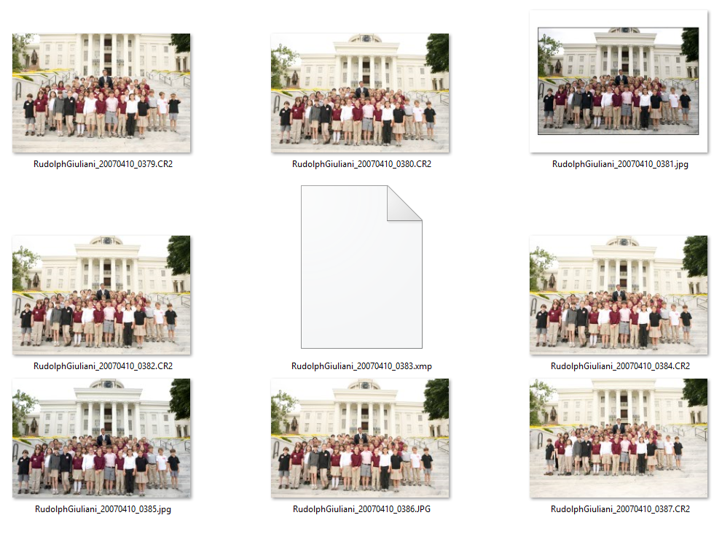

* Photos to Keep

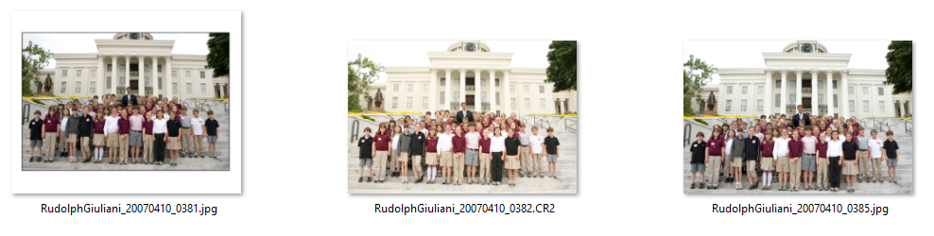

Example 1.3 - Speeches

When there are many highly similar photos of one speech, the reviewing archivist decides to retain a few images based on aesthetics (focus, lighting, pose) and chooses photos that are representative of Governor Riley’s speech style (flourishes of his hands, different faces such as laughing or serious) to give a visual idea of how he spoke.

One to three photos are chosen from each angle taken during the speech to ensure proper coverage.

Note that Collections staff determined that sideways photos should not be rotated during weeding, which is a review stage before processing. Photos will be rotated upright as necessary during processing.

* Highly Similar Photos Received



* Photos to Keep

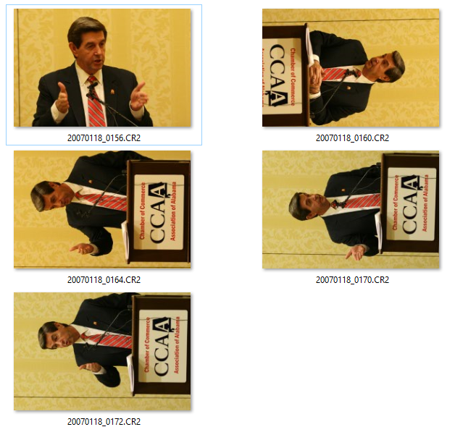

Example 1.4 - Taking Background People into Consideration

Event or meeting photos may involve crowds or movement, and so the particular people in view may change slightly from photo to photo.

To ensure adequate representation of those present at events/photo-ops, figures in the background are taken into consideration so as to preserve as much as possible a complete representation of the attendees.

* In the example below, the photo on the left would be weeded out, as the same background people seem visible in both pictures.

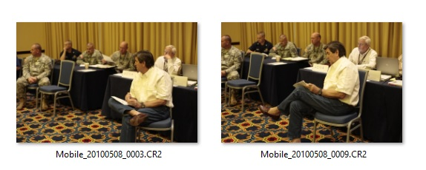

**2. Weeding of Photos Without Identifiable Subject or Purpose**

Many photos in the Riley transfer appeared to be virtually random. In this case, the photo does not provide sufficient identifying information or event context. The photo may not involve any people at all. Collections staff would consider these to be transitory rather than permanent records, and they are thus recommended for weeding out.

Example 2

* Photos to Weed Out

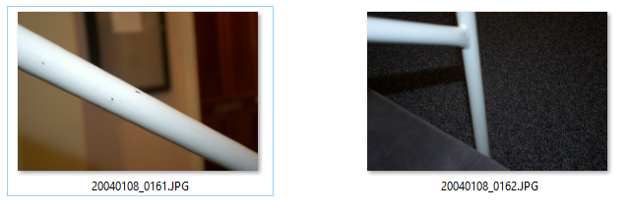

**3. Weeding of Unflattering Photos**

People generally prefer not to be displayed in an unflattering manner; however, photos can capture people’s faces in awkward positions (eyes closed, mouth contorted, etc.).

When multiple photos of the same composition and context are compared, an effort will be made to preserve the image that is overall more pleasing and void of closed eyes, contorted facial expressions, etc.

Example 3

* Photo to Keep

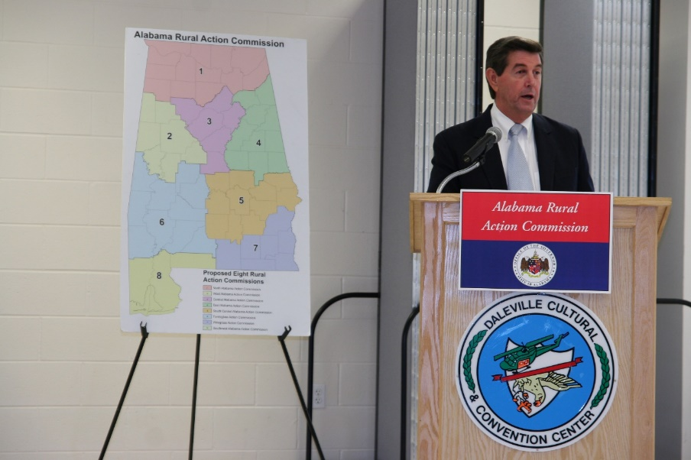

* Photo to Weed Out



**4. Weeding for File Formats**

Where both a CR2 file (proprietary raw format) and unprocessed JPG file of the same photo shot are included, the unprocessed JPG would be recommended for weeding out. Retaining the CR2 file is preferable due to the format’s inclusion of additional photo-related data.

* Example 4

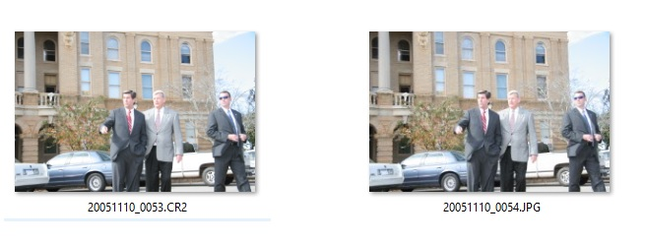

Acknowledgment

This weeding memorandum was completed as part of a three-year electronic records project funded by the National Historical Publications and Records Commission.

1. Tom de Castella, “Five ways the digital camera changed us,” *BBC News Magazine*, January 12, 2012, accessed July 21, 2017, http://www.bbc.co.uk/news/mobile/magazine-16483509.
2. “Weeding,” Society of American Archivists, accessed July 17, 2017, https://www2.archivists.org/glossary/terms/w/weeding.
3. Note that weeding and deaccessioning are not the same thing: “When we *deaccession* we permanently remove an entire collection from the Archives, while *weeding* is a part of the process of cleaning, processing, and describing a collection.” Marisol Ramos and Alma C. Ortega, *Building a Successful Archival Programme: A Practical Approach*, (Oxford, England: Chandos Publishing, 2006), 39.
4. Mark A. Greene and Dennis Meissner, “More Product, Less Process: Revamping Traditional Archival Processing,” *The American Archivist* 68 (Fall/Winter 2005): 208-263 (about paper records). Opinions on weeding vary. Greene and Meissner conclude that weeding should only be used in exceptional circumstances, but they cite multiple manuals that direct the use of weeding. Both the [Minnesota Historical Society](http://www2.mnhs.org/library/findaids/CMToolkit/BestPractices/BestPractices_Physical-Processing.pdf) and [University of California Libraries](http://libraries.universityofcalifornia.edu/groups/files/hosc/docs/_Efficient_Archival_Processing_Guidelines_v3-1.pdf) agree with the exceptional circumstances approach. ADAH Collections staff believe that the Governor’s photos are of such importance that they merit item-level processing and thus item-level weeding, consistent with the exceptional circumstances approach outlined by the three sources in this footnote.
5. Alabama Office of the Governor, Functional Analysis & Records Disposition Authority (presented Oct. 23, 2013), http://www.archives.alabama.gov/officials/rdas/Governor_RDA_2013.pdf.
6. The processed version can be distinguished by the appearance of a lower-case “.jpg” file extension rather than the upper case “.JPG.” The modified files may also have a white border. Sometimes there are multiple ‘.jpg’ processed photos created from the same original image.